ART TECHNIQUE USED IN SPELEO ART
June Maclucas (BFA)

The technique of Chiaroscuro used in 19th Century engravings of caves and its use in charcoal drawing today.

In the past art was viewed not so much for pleasure but for documentation. The contents of art in most instances were subject to political, social and religious influences of its time, often recording in full detail much of western history.

About 200 years ago brought about in part by the Industrial Revolution as well as the great explorations of new continents, visual appreciation changed. Interest was expressed more in the harnessing of power, especially through nature with all its splendour by recording the effects of atmosphere seen in the work of Turner and the fall of light as seen through the work of Constable. Documentation of history, politics and religion still had sway but art was moving forward incorporating a wider field by recording the grand splendour of “The New World”.

At the beginning of the 19th Century an exciting new period developed that was called “The Sublime and Beautiful”. It originated with Edmund Burke from his essay of the same title in 1756, (Hamilton-Smith, 1997). This period looked at the frightening aspects of nature with its mystery, scale, beauty and power. At this time archaeological exploration was taking place in Greece, America and Australia was opening up, artists were travelling to remote continents to record the splendour of the new found “wilderness”. This new exciting view of the world included paintings of caves revealing rich colours of gaping holes and deep dark chasms. Many works were depicted with tiny figures used as a device to enhance the view to absolute grandeur and beauty regardless of its true scale. In this way by distorting the true scale, the view would appear as huge frightening renderings of nature, the absolute essence of The Sublime and Beautiful.

During this period engravers used woodcuts to produce a relief print in order to reproduce images particularly for newspapers and books. Here engravers would work from sketches or notes and later photographs to record what surveyors brought back
from their explorations. Most engravers of this period were unknown as artists in their own right as they had to work from whatever documentation was handed to them. But history records that in many cases artists themselves joined expeditions, travelling out to unknown territory recording the many wonders that confronted them.

Translating images to suitable methods for publication

The Relief Print
As the term suggests, the design (whether composed of images, decorative elements, or even text) appears in relief – that is, it stands away from the lowered or carved-out background. Centuries ago, before the Christian era, relief sculpture was used to decorate the walls of tombs and palaces, eg in Egypt the magnificent bas-reliefs in the valley of the kings, where images of figures were carved out with their backgrounds lowered to create striking contrasts of light and shadow. This was used to heighten the dramatic effect and to give depth to the image.

In the relief print, or woodcut, artists used the same principle as the ancient sculptor but now worked on a wooden block, not to produce a work of sculpture, but as a technique to reproduce an image to be printed many times.

The Woodcut
A method first developed in Europe during the fifteenth century. Using the principals of a relief print a design or image was drawn on a piece of smooth hardwood, ink smeared over the surface and a piece of paper placed over the top and pressure applied usually by a wooden press leaving an image in reverse.

The Wood Engraving
An invention that is a variant of the relief method dating from the 2nd half of the eighteenth century. The English engraver Thomas Bewick found that if he used the end block (a cross section of the tree), he would have an extremely hard surface which resisted splitting and splintering revealing a delicate use of fine line etched closer together that was more durable producing larger editions. This was the method used to produce the many fine engraved images of the 18th-19 century.

The Metal Cut
The metal cut used from the fifteenth century is a relief print cut into copper or some other metal offering a similar result as the woodcut where raised areas are printed black and lowered areas remain white.

An example of the metal cut method can be seen in William Blake’s illustrated poetry manuscripts. He employed metal cuts for his publishing adventures developing a method of using acids to eat out areas in order to enhance the background of his images.

Using metal - The Intaglio Print
The opposite of engraving, where the lines are cut, scratched, or bitten into the plate by acids, so that all lines lie below the surface of the material on which they are drawn. Ink is forced into the lines that have been cut into the soft metal, usually copper. The surface of the metal is wiped clean, the ink remains in the furrows or cuts of the design. To produce an intaglio print, paper is dampened and placed on the surface and run through a press under considerable pressure. Hey presto, you have a beautiful delicate impression of whatever image you wish to produce.

Working with the Image
19th Century images of caves were mostly rendered through the form of woodcuts, drawings and paintings, with woodcuts being the main medium of execution. This was by far the easiest and most dramatic way to present powerful images collected from surveyors and explorers to be presented to a mass audience. All, or most artists of this period had learnt the techniques of chiaroscuro, rendering form by the use of light against dark.

Chiaroscuro – The form of rendering light against dark
The term chiaroscuro was first used by Renaissance masters to describe the painter’s method of modelling figures by strong contrast of light and dark areas. Chiaro is an Italian word for light, and oscuro, is the word for dark, they are combined to create this descriptive adjective. Used effectively this method produces stunning effects dramatised by strong contrasts. With wood or metal engravings offering a black and white image, chiaroscuro was the method most engravers used to portray their images in the strongest most dramatic way. This method then offered power with control and ruled as a device as a way of producing images to the present day.

This is why when confronted with an image of a cave executed in this method your interest is drawn immediately to the contrasts, you have no choice, it offers power and strength and you are drawn to it, that is what we associate with caves. Chiaroscuro portrays subtle changes of light against dark areas working it’s way up and around holding the viewer’s eye and interest throughout the design. It has power in that you can use it's strongest contrasts to work at it's fullest attraction or to the most gentle soft renderings, like the play of soft lights that travel around throughout the work, keeping it all together as a whole picture allowing your eye and mind to stay with the design. This is a device, a power to capture the viewer and it works every time. Black and white images offer drama by its shear contrasts, colour provokes emotion but that’s another story.

Unfortunately photography in the 20th Century brought this method of working through prints to a virtual stand still, especially depicting caves. It was a tedious, arduous method of working for a small specialised audience.

A few examples of 19th Century wood engravings of Australian Caves.

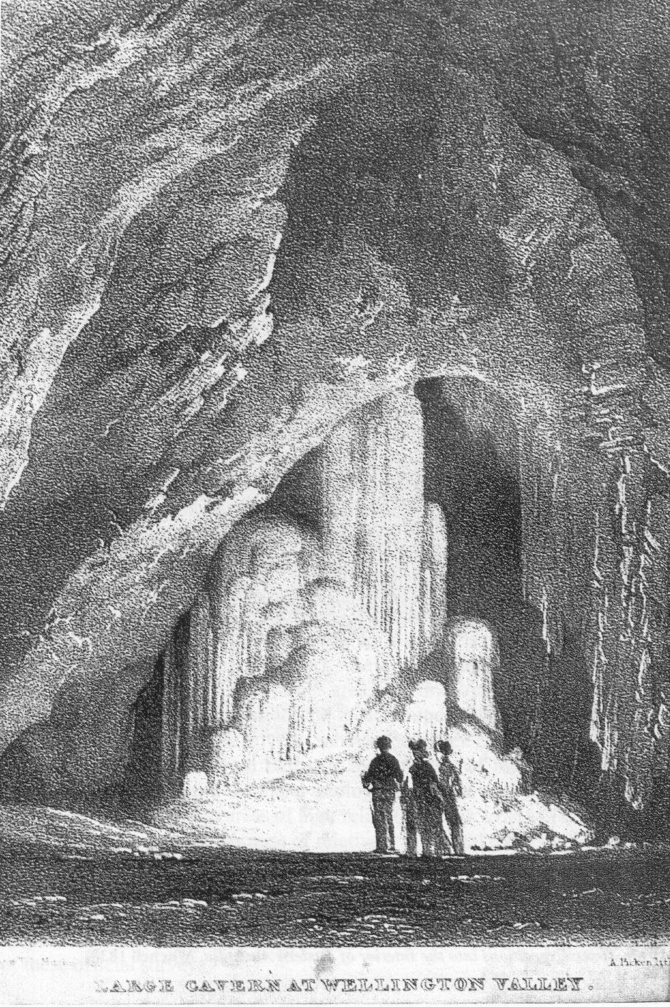

Figure 1.(previous page) Mitchell, Thomas L. 1838, Wood Engraving, Large Cavern at Wellington Valley, from his book, Three Expeditions into the Interior of Eastern Australia.

The soft play of lights throughout the background is gentle while at the same time taking control by bringing the eye up and over the image to take in the contrasts of the centre attraction, the people in the foreground with full contrasts.

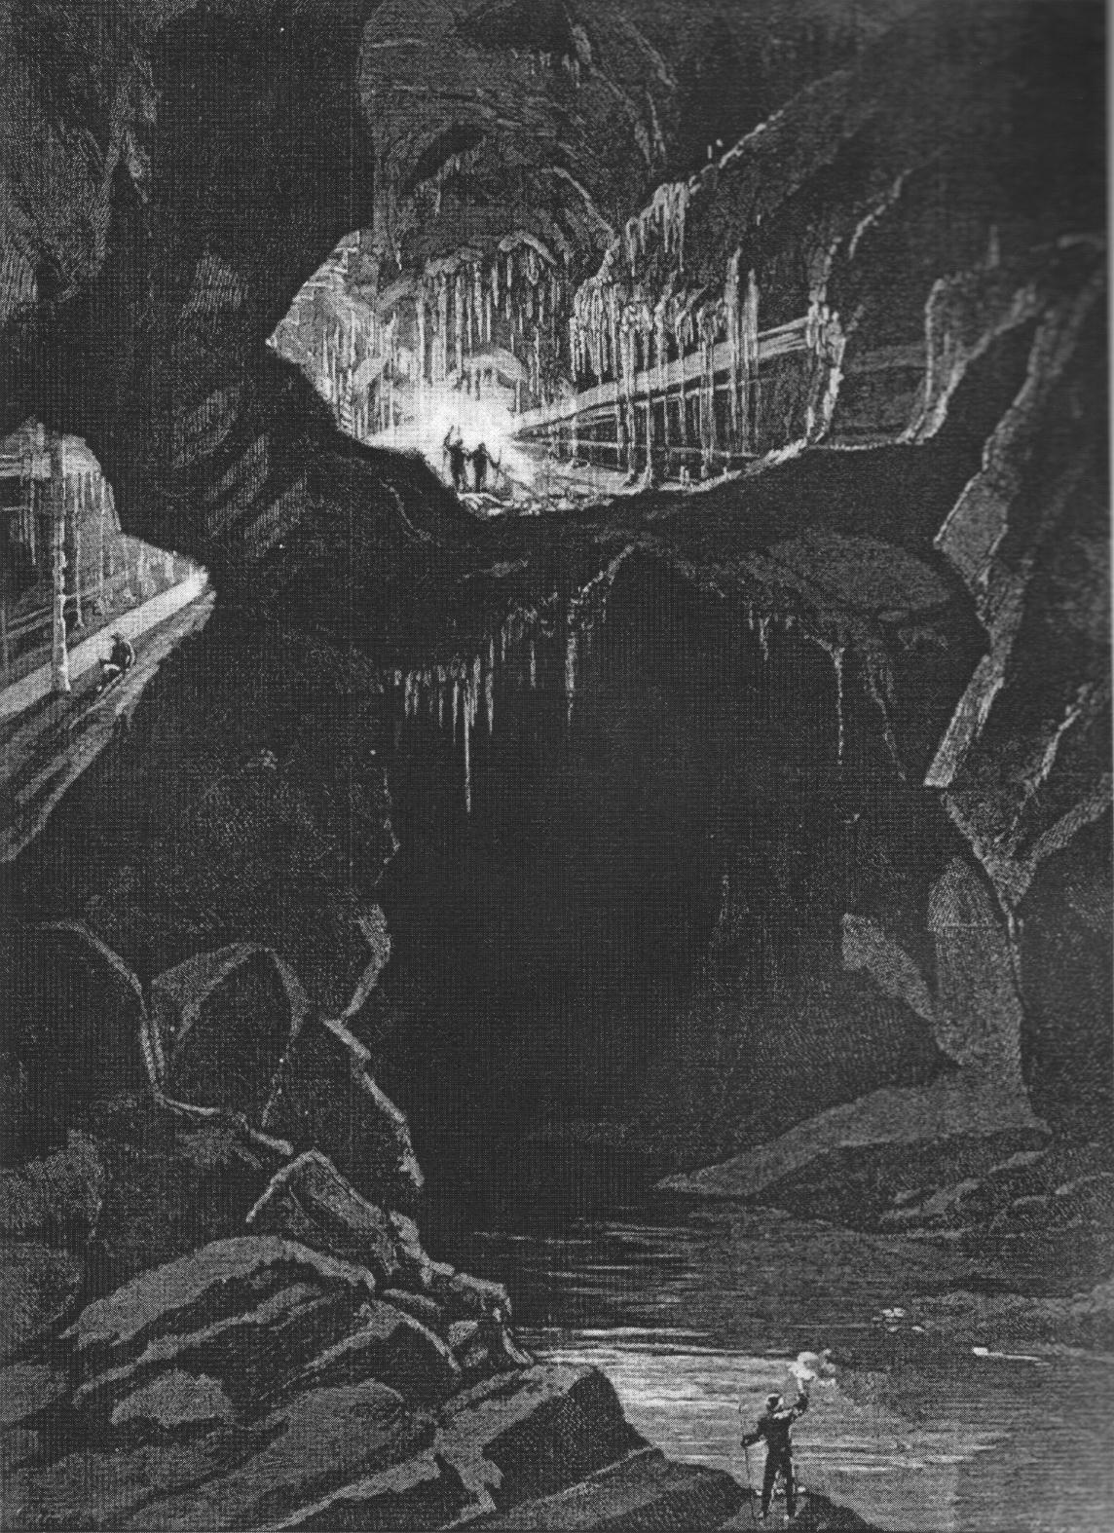
Figure 2. Collingridge, George. 1880, Wood Engraving, The Fish River Caves, near Bathurst, NSW
This image uses the full power of black and white by drawing your attention to two small figures in the centre of the arch that frames them and at the same time presents a sense of scale. Another device is to balance the work by using a figure in the foreground placed down the bottom of the picture. This draws your attention into the dark space in the middle. Notice the use of chiaroscuro throughout the work to hold it all altogether. One should never endlessly fill in black areas, there is always something happening in the dark space

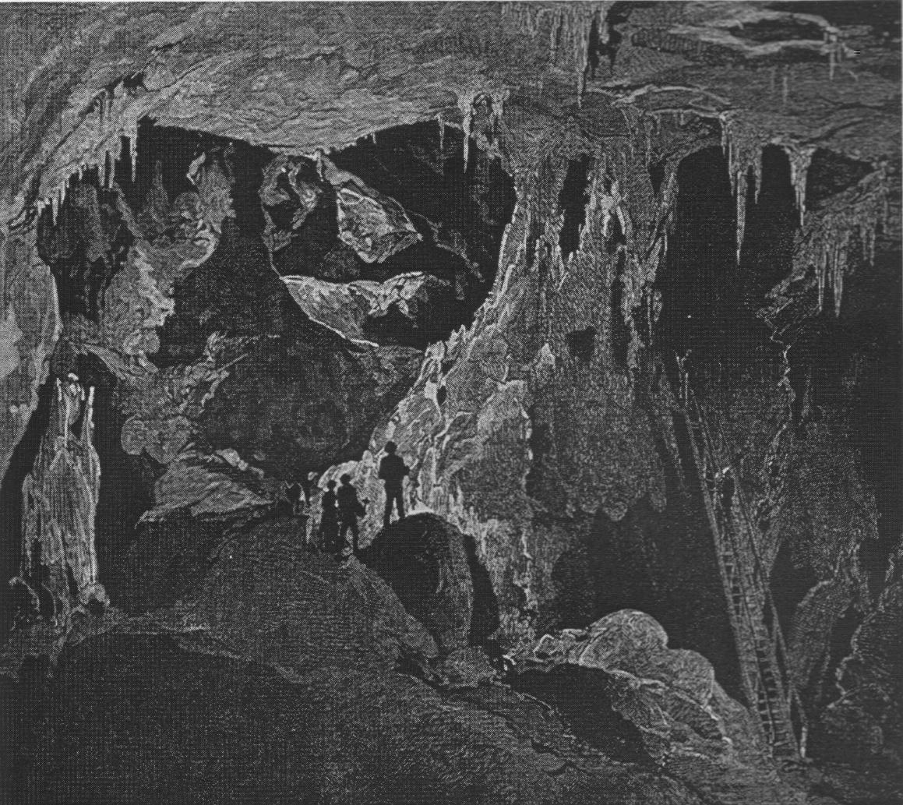
Figure 3. Unknown artist, The Arch Cave, Looking North, from the Picturesque Atlas of Australasia.
This is an interesting image, in that it has light coming from two directions which is a bit confusing at first, but on a closer inspection, its rather clever as it takes the viewer up and through the centre of the work using figures once again for scale while at the same time allowing chiaroscuro to do its work by taking the viewer up to a higher level. This is a chamber called “Judges Wig” in Nettle Cave, Jenolan.

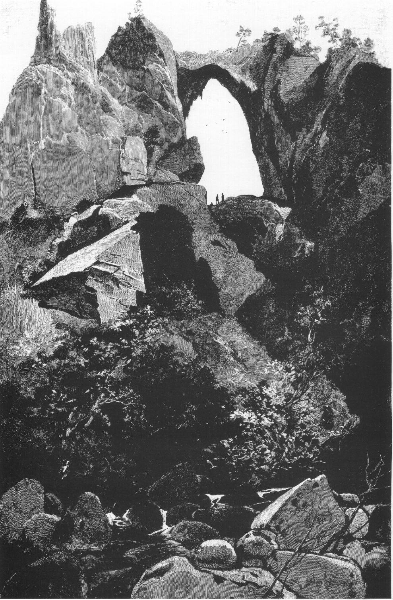

Figure 4. Carlotta Arch, Jenolan Caves, Negri’s engraving from the Picturesque Atlas of Australia.
This image uses the full available techniques, the different values of soft greys used in rendering the foreground leading up to the dramatic framing of the small figures used for scale within the arch.

Using the same principles, but using charcoal.
To achieve the same strong effects of black and white images produced with etchings, you can accomplish to some degree through the use of charcoal. Charcoal is a wonderful medium for spontaneous quick impressions, whether it is represented by only a few marks or a detailed fully scaled up drawing. You can work quickly covering the paper with a variety of marks to produce the image before you. Working with charcoal is made by building up a series of marks on paper that offers the full scale of greys from the lightest soft grey to rich bold blacks. Just one stick of charcoal offers you an endless variety of mark making by using the fine crisp end of the charcoal for hard bold defined edges or by scrapping the charcoal on its side pressing hard for large deep black areas. You can produce soft masses of grey areas to create a sense of mystery or leave areas stark white for contrast. Charcoal offers an endless variety of ways to work. With very black drawings you can highlight areas by using a hard rubber or a putty rubber and pick out areas by removing the charcoal. There are many possibilities, which ever way you choose to portray the image before you, think of the principles of chiaroscuro, light against dark/dark against light creating drama and strength throughout your artwork and at the same time the principles of chiaroscuro will help render the forms before you.

For beginners or accomplished artists alike, charcoal is a wonderful medium offering you the ability to record with confidence and speed. To record caves while on the run it’s the ideal medium, it offers the strongest instant contrasts available. Don’t be afraid to use it, try it next time you are out there, you maybe surprised at the image that unfolds before you. Oh by the way, you will need a damp towel; charcoal is a bit messy.

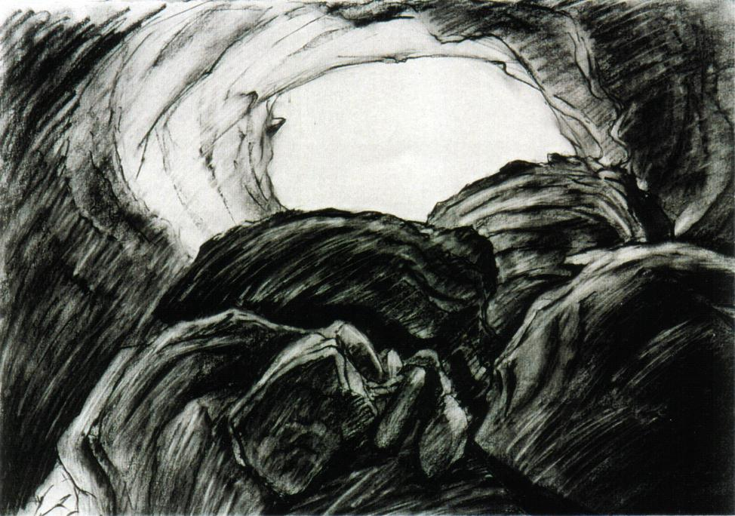

Fig 5. MacLucas, June 1999, Charcoal drawing, Knowles Cave, Nullarbor.

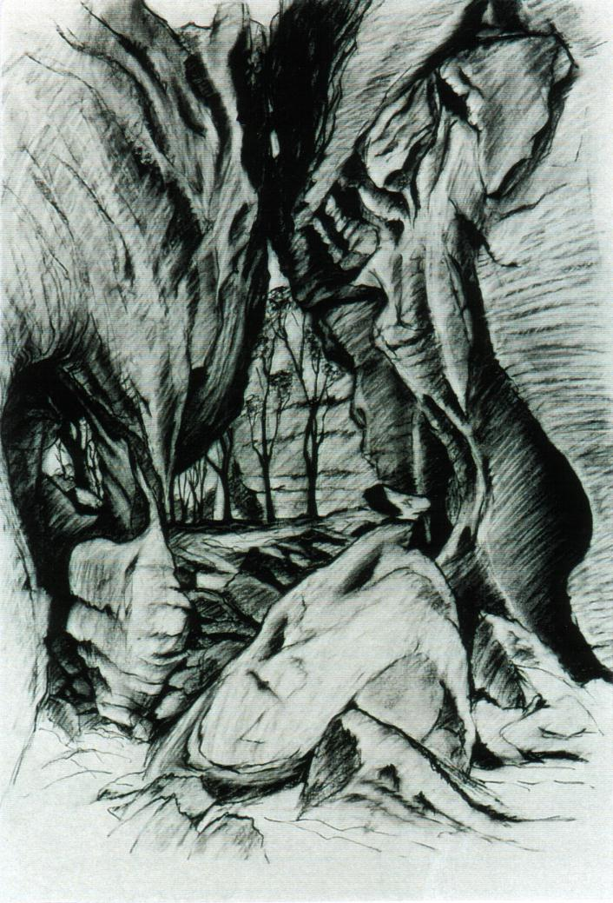
Fig 6. MacLucas, June 1999, Charcoal Drawing, Golden Arches, Gregory National Park NT.
Both charcoal drawings (figs 5 & 6) were completed while in the field, both measuring 86x64 cm using Italian Magnani etching paper.

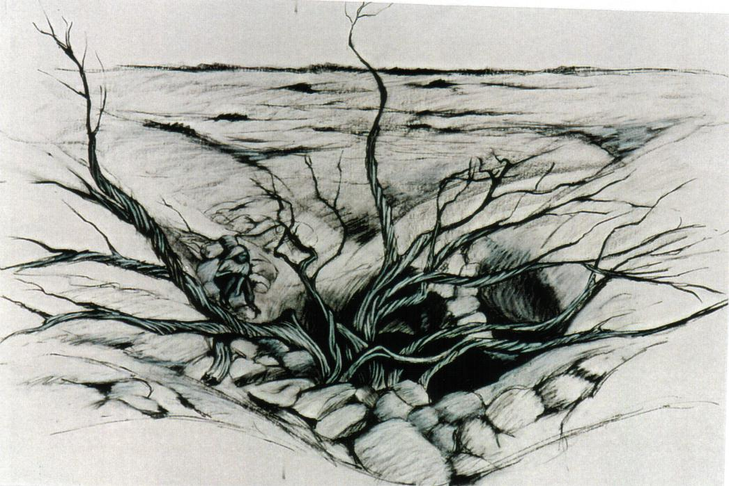
Fig 7. MacLucas, June, 1999, Charcoal drawing, Koomooloobooka, Nullarbor.
This particular drawing was completed in my studio using several of my own photographs, plus several supplied by Ken Boland, (VSA) Victoria. Size 86x64cm using Italian Magnani etching paper.

Fig 8 Watson, Tony 2000. Inside Devil’s Coach House, Jenolan.
First attempt at sketching with charcoal during Cave Art Workshop at ASF Conference – Bathurst December 2000
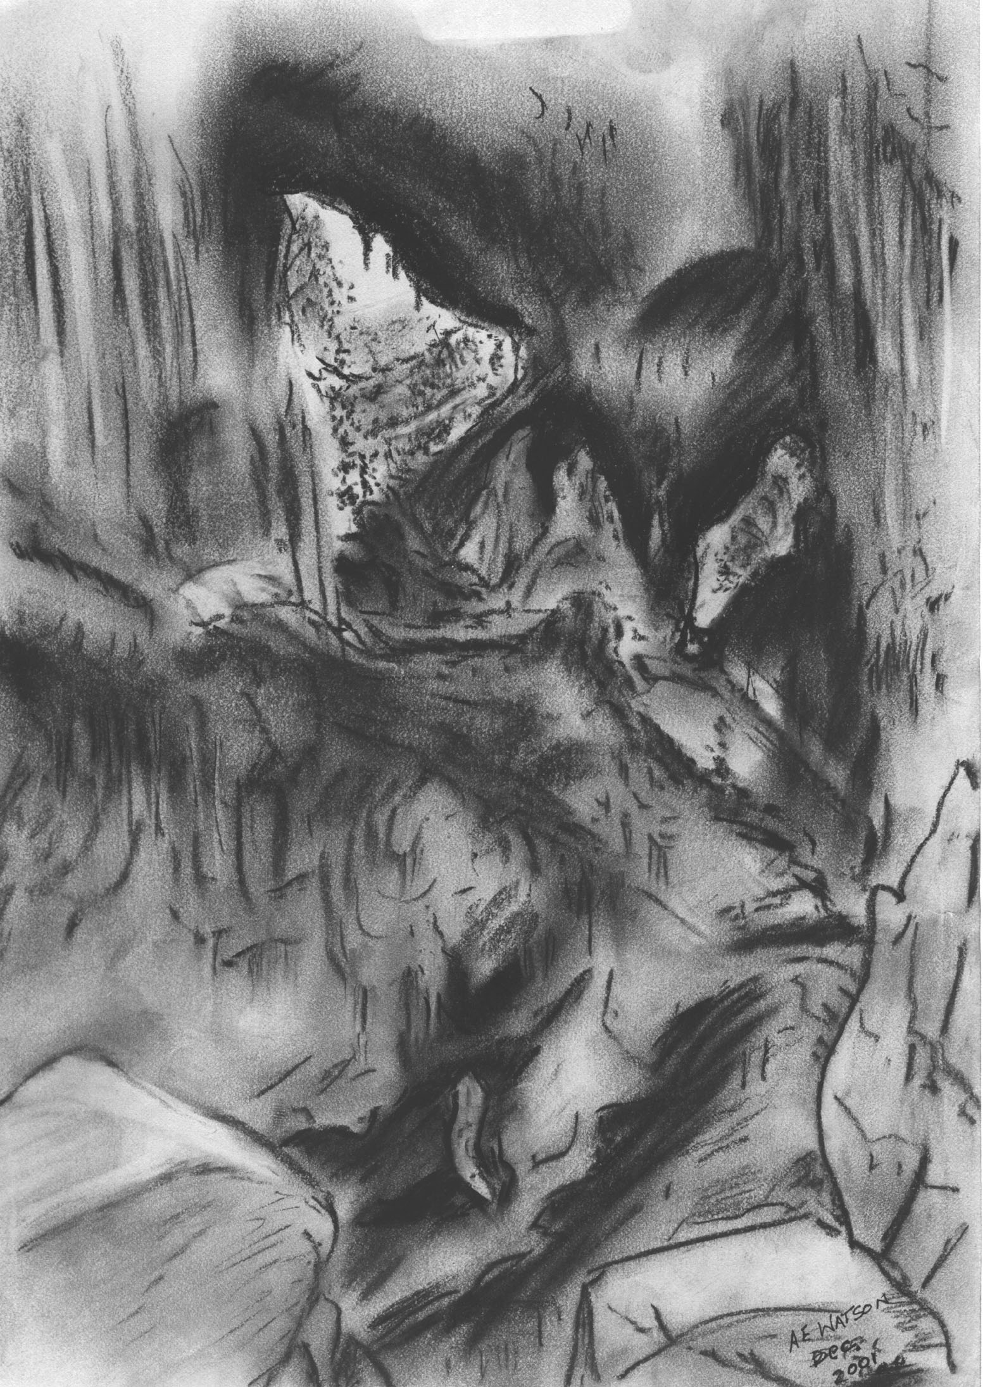

.

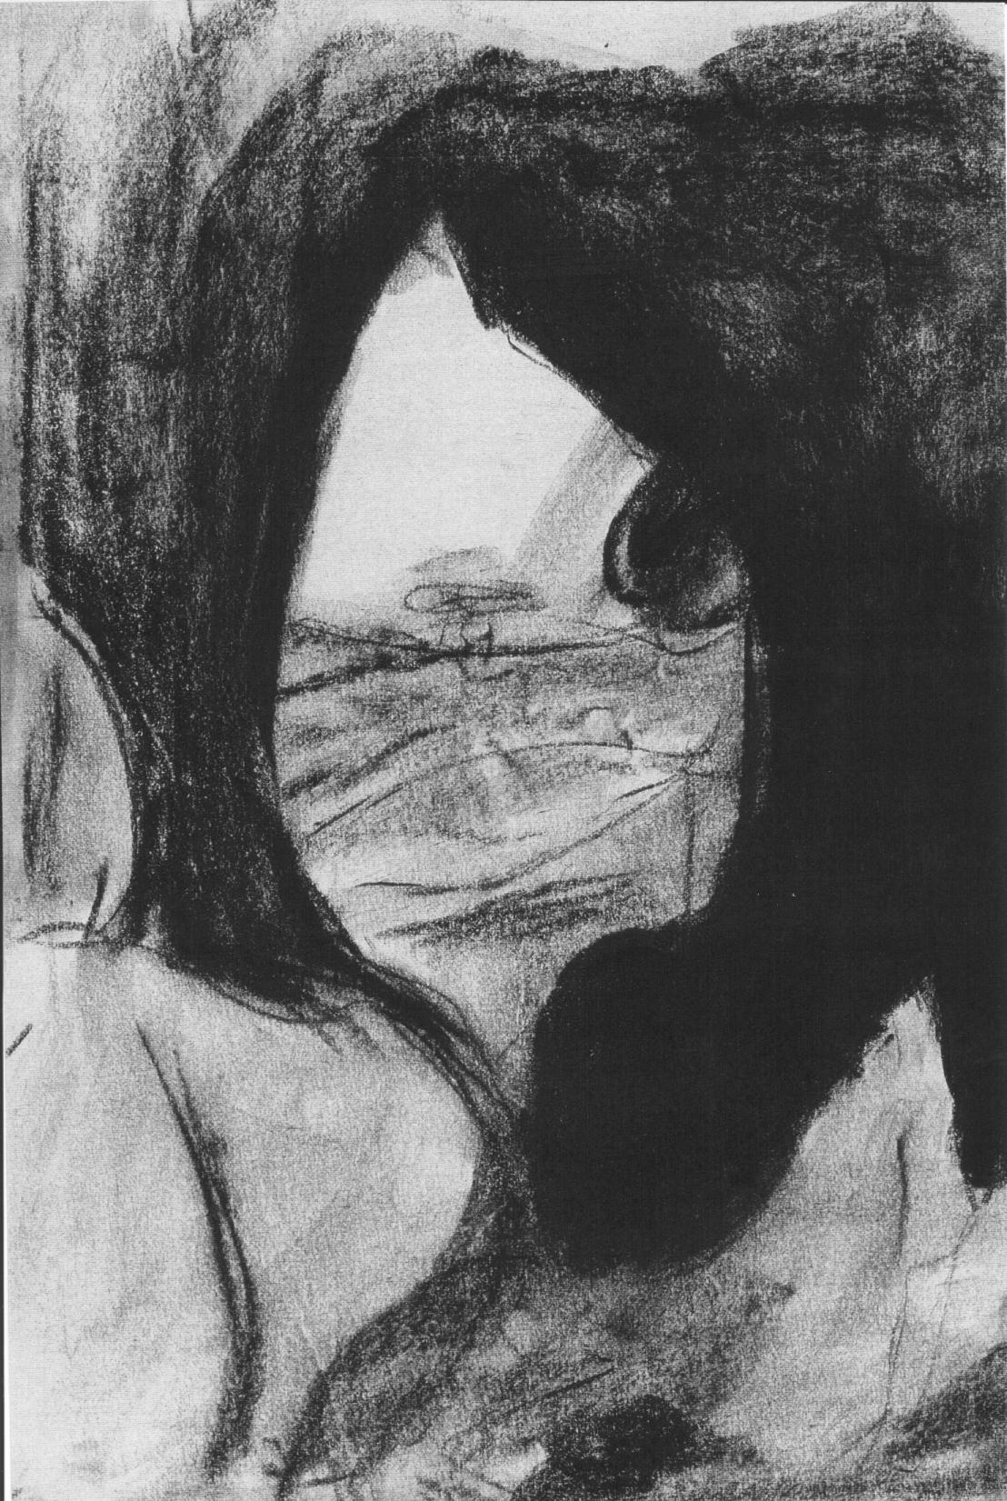

Fig. 9 Gibbons, Ray. 2000. Looking out from Devil’s Coach House, Jenolan.
First attempt at drawing during Cave Art Workshop at ASF Conference – Bathurst December 2000.

REFERENCES

ANTREASIAN Garo, ADAMS Clinton, (?) The Tamarind Book of Lithography:
Art & Techniques. Tamarind Lithography Workshops. NY

DUNKLEY, John. 1986. Jenolan Caves. As they were in the nineteenth Century.
Speleological Research Council Ltd.,

HAMILTON-SMITH, Elery. 1997. Perceptions of Australian Caves in the 19th
Century: The Visual Record. Nineteenth Century Paintings, Drawing
And Engravings of Australian Caves. Helictite Journal of Australasian
Speleological Research. Vol. 35 (1&2) 1997.

WECHSLER, Herman F. (?) Great Prints & Printmakers, Leon Amiel NY.

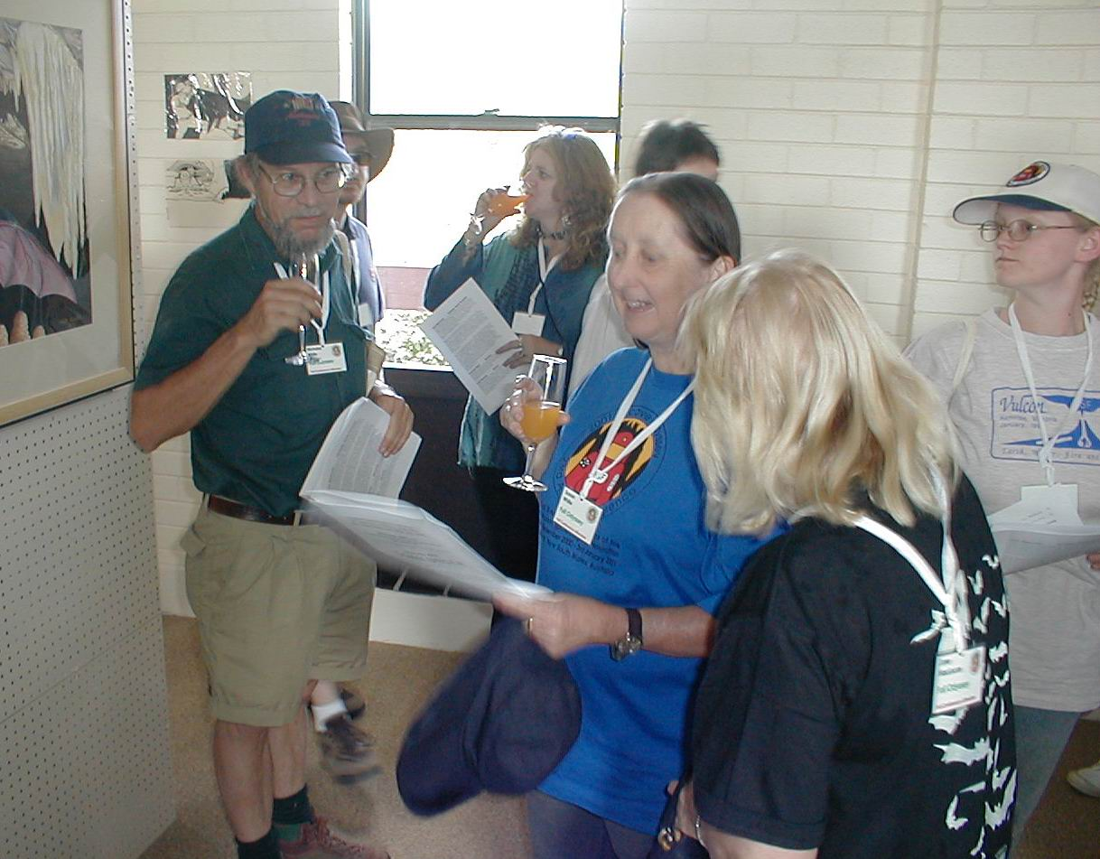
Arthur Clarke
Nick White, Bruce Waddington, Marie Choi, Sue White, ?, June Maclucas, and Erica Maggs at the Art Exhibition opening

Maps of Australian Caves and Karst

John Dunkley

Introduction

In 1996 I was approached by the Australian Map Circle to present a paper on maps of Australian caves at their Conference in Canberra.

It soon became evident that information on the subject was voluminous but scattered widely, and there was no compilation. I therefore selected just a few themes to illustrate the scope of the subject without any pretence of a comprehensive survey, especially beyond New South Wales. The paper elicited considerable interest as it raised issues not normally occurring to the audience of professional cartographers, map curators and collectors. It led directly to the National Library of Australia commencing a collection of cave maps.

The original paper was published in The Globe, No. 44, 1996, pages 41-44 and was intended to be expository rather than definitive and aimed at cartographers and curators rather than cavers. The paper is republished here in slightly amended form to increase accessibility to speleologists.

Historical Cave Maps

Caves occur in a host rock, usually but certainly not necessarily limestone. They form an integral part of an assemblage of landforms, characterised by solution processes and known as karst. It is thus common for modern cave maps also to relate to surface landforms as part of a karst map. Such maps now form an important contribution to the recording of our nation’s heritage.

Although caves have been utilised by man for many thousands of years and were first recorded perhaps 3,000 years ago, the earliest extant cave map may be that published by Georg Agricola in Basel in 1546. It represents a set of branching tunnels called the Stufe di Nerone (Nero’s Oven), excavated in volcanic tuff near Naples.

Australia’s earliest known cave map was drawn in 1827 by Surveyor Henry Hellyer as a rough sketch in his notebook, and has only recently come to light in the archives of the University of Tasmania (Middleton 1990). A sea cave in quartzite, North Cave is at Rocky Cape on the north-west coast of Tasmania. Its archaeological significance was realised even then, and several excavations were made in subsequent years.

The earliest known published maps are those of John Henderson (1832). On furlough from Bengal, Henderson made an extensive, privately funded journey from Sydney to Bathurst and Wellington in the second half of 1830, later traversing unexplored country easterly to the Hunter Valley and thence to Sydney. In a discussion of his theories regarding the origin of the red earth and bones, he produced sketch plans (without a scale) of ‘Boree Cave’ (Tunnel Cave, Borenore, BN-25) and of ‘Wellington Cave’ (i.e. Mitchell Cave WE-5). His notes also include a diagrammatic cross-sectional sketch of the Arch and karst at Borenore.

Surveyor-General Major Thomas Mitchell had also visited Wellington in June 1830. Curiously neither Mitchell nor Henderson mention the other’s visits to the caves at most a few days apart; intellectual rivalry was probably at work (Dunkley, in this volume). In his Three Expeditions into the Interior of Eastern Australia, Mitchell included maps of what he called ‘Large Cave’ and ‘Breccia Cave’ at Wellington, the former being the present Cathedral Cave which is shown to tourists, the latter now known as Mitchell Cave (WE-5). These journals were not published until 1838, whereas Henderson was in print by 1832, and in the meantime also a cross-sectional view of ‘Gudarigby Caverns’, near Yass, was produced by George Bennett in 1832 and published in 1834 (Bennett 1834). The latter is intermittently flooded by Burrinjuck Dam and is well-known to divers.

From this beginning, three distinct phases of interest in cave maps can be recognised. From 1830 to about 1900 leading naturalists and geologists visited caves and successfully encouraged official support for their study, mapping and reservation. In the second, low activity phase from 1900 until about 1950 there was little interest in caves from any part of the community, other than for tourism, although a few early maps have recently become known (see for example Cooper et al. 1998). From 1950 onwards there has been an awakening interest, pioneered by recreational speleologists whose maps have in turn been utilised by scientists and environmentalists. The dominant driving forces have thus been paleontology and cave tourism up to the early years of this century, and recreation, geomorphology and resource documentation in the last 50 years.

For most of the first period bone hunters and paleontologists studied many sites mainly in eastern New South Wales and the south-east of South Australia, their reports and the significance of the sites then lying dormant for as long as a century. In 1881 Charles Jenkins was employed to search for fossil bones, producing a map of Cave Flat Cave at the curious scale of 20 feet to 1 centimetre NSW Parliament, 1882). Late in the nineteenth century a new factor, tourism rather than science became the driving force, and then, as now, governments wanted to know what resources they had. In 1896 the remarkable Oliver Trickett was appointed Superintendent of Caves in New South Wales, a position he retained until in 1906 the caves were transferred from his employer, the Mines Department to the Tourism Department. Being a licensed surveyor, Trickett commenced a program of surveying tourist caves throughout the state, much of it undertaken in his spare time (Middleton 1991). He published superb maps, many in colour, in Annual Reports of the Mines Department and in his series of Guidebooks to the Jenolan, Wombeyan, Yarrangobilly, Abercrombie and Wellington Caves. He also constructed three dimensional models, most of which have disappeared although photographs exist. His model of the Imperial Cave is displayed in the visitors centre at Jenolan Caves. Trickett’s influence is seminal and a century later his maps continue to inspire speleologists and latter-day cave surveyors.

There are few records of cave exploration in the period between the two World Wars. Maps of Tuglow Cave were prepared separately by Glanfield et al. in Easter 1934 (Cooper et al. 1998) and by Harper & Salmon in September 1934, the latter being unrecorded for over 60 years, along with some Tuglow sketches by R.N. Bracewell dating from 1939 (Dunkley, in prep). Oliver Glanfield’s map of Colong Cave ca. 1935 was widely used for the following 50 years or more. Noske and Welch produced maps of Mammoth Cave, Jenolan in 1942 (Dunkley & Anderson 1972).

In 1946 Australia’s first speleological society was founded in Tasmania. From this point enthusiastic and often well-qualified amateurs have dominated the exploration, documentation and mapping of Australia’s caves. In 1956 the Australian Speleological Federation began coordinating this work. It has established standards for cave mapping relating to the accuracy of survey instruments and the recording of information in symbolic form on maps, and maintains a database on some 10,000 caves, for which there are maps of over 2,000.

In the 1950s and 1960s the task of cave surveying was immensely laborious and there had been no technological advances since Trickett’s day. Theodolites or miners dials of varying degrees of antiquity were utilised, survey reductions were performed manually using trigonometrical tables, and the maps were plotted by hand. Today, cheap and accurate light-weight, hand-held compasses are used, calculations and plotting are driven by computer, and GPS instruments enable cave entrances to be plotted accurately. Comprehensive inventories of cave and karst features are then compiled for land management authorities.

The magnitude of the task and its essentially amateur nature means that the results are scattered widely among 30 clubs and many individuals. However compilations of maps have been published for many areas e.g. Jenolan, Bungonia, Tuglow and Timor in New South Wales, Mt Etna, Chillagoe, Mitchell-Palmer and Broken River in Queensland, the south-east of South Australia, and the Nullarbor Plain, among others. The value of this collection is incalculable and severely underrated by many land managers and scientists. Amateur output is, of course, not captured by statistics of Gross National Product, but the notional cost of the map of cave systems of Gregory National Park in the Northern Territory has been conservatively estimated at about $300,000, including $100,000 in actual out-of-pocket expenses, over $170,000 in on-site labour and $30,000 in off-site processing and drawing. On this basis the notional production cost of cave map collections in Australia is of the order of maybe $20 million, even after discounting many of little likely significance to scientists, land managers and recreational interests.

The use of cave and karst maps

Cave and karst maps serve many purposes: recording history, inferring underground hydrology, a convenient means of recording scientific information, route finding and visitor interpretation. Graffiti on cave walls enables us to reconstruct exploration history and infer visitor usage in former times.

Some have been produced under the pressure of environmental disputes, and the very existence of cave maps was instrumental in promoting conservation objectives and refuting ill-informed criticism of development proposals. For example, exploration and mapping of caves in southern Tasmania established that drainage from a quarry into one cave led underground to another large cave in a World Heritage Property, thereby invoking the powers of the Commonwealth Government which eventually forced the quarry to close. In parts of South Australia and Florida, mapping of underground aquifers has established flow patterns of polluted groundwater.

Good maps of caves enable geologists to infer their mode of origin and a large literature exists, using cave maps to relate geological structure and solution processes to the development and present-day appearance of caves. Plans that reveal linear, anastomosing or network mazes each reflect differing dominant modes of cave origin and development. Cross-sections frequently highlight the existence of two or more phases in cavern development; Jenolan Caves for example may be developed on at least five levels corresponding to at least five periods of active development.

Caves are three-dimensional voids within a host rock and several techniques have developed to improve visualisation and perception. Conventionally, an attempt was made to display the cave as a spatial object by some form of orthographic projection, in plan, long-section and cross-section, corresponding to the three spatial dimensions at right angles.

An obvious limitation of this system is that only detail which is roughly parallel to the projection plane can be represented with little distortion in any one view. In any such view, one projection plane is favoured at the expense of the other two. The problem is that most cave maps are not simple spatial objects conveniently parallel to one plane. Most are twisted through at least two of three dimensions.

An isometric projection enables the 3-dimensional nature of the projected object to be revealed in a single view, but this is still feasible only if key passages are parallel to the reference axis. Such diagrams are excellent for overall visualisation of the cave but on the other hand it is difficult to depict detail of floor deposits which are frequently important to scientists as well as cavers.
Experiments have also been conducted using stereographic projections, a technique particularly suited to deep vertical caves such as those in Tasmania. Specialised computer programs enable the plot to be rotated to any desired orientation, and stereopairs may be obtained from two views about 5⁰ apart. The same program will also project the diagram on to any or all of 3 planes intersecting at right angles, and from surface elevation data can construct a representation of the surface above.

So far most of these non-conventional projections have been used for recreational or general purposes of illustration. For specific purposes, however, diagrammatic maps often convey information more clearly (see, for example, Dunkley & Anderson 1972). Maps of underground hydrological networks are often simplified isometric projections. Examples include a representation of underground drainage in the Junee-Florentine region of Tasmania (Eberhard, 1994. p. 27).

Geographical Information Systems software offers new opportunities for integration of cave maps with other resource data to assist environmental management planning. Cave passages can be shown in relation to surface features and/or geological structure, and different levels of passage, for example, can be printed automatically, either selectively or in different colours. Some fine examples have recently been produced by Canberra Speleological Society of Bullita Cave, Northern Territory.

Ultimately, the worth of any given method of presenting cave maps or diagrams must be assessed by those who might use them. The problem is analogous to that presented by the question of how to represent the globe as a two-dimensional map. Constant scale and/or direction are sometimes sacrificed for a specific objective. It depends on what you wish to use it for – there is no single correct representation.

References

Bennett, G.(1834): Wanderings in New South Wales, Batavia, Pedir Coast, Singapore, and
China, being the journal of a naturalist in those countries, during 1832, 1833 and 1834,
London: Richard Bentley, 2 vols, 441pp. Facs. Ed., 1967, Adelaide: Libraries Board of
South Australia.
Cooper, I., Scott, M. & Vaughan-Taylor, K. (1998): Tuglow Caves, Sydney: Sydney University
Speleological Society, 67pp.
Dunkley , J. (assisted by E.G.Anderson) (1972): The Exploration and Speleogeography of
Mammoth Cave, Jenolan, Sydney: Speleological Research Council Ltd., 53pp.
Dunkley, J.R. (2002): Explorers, Surveyors, Missionaries and Travellers: the first
chapter of Australian speleological history 1788-1838, Proc. 23rd Biennial
Conference, Australian Speleological Federation Inc. (in this volume)
Eberhard, S. (1994): Inventory and Management of the Junee River Karst System, Tasmania, a
Report to Forestry Tasmania. Unpublished internal report.
Henderson, J. (1832): Observations on the Colonies of New South Wales and Van Diemens Land,
Calcutta: Baptist Missionary Press, 180pp.
Middleton, G.J. (1990): Rocky Cape North Cave – an early cave map from Tasmania. Jnl
Sydney Speleol. Soc. 34 (11): 213-216
Middleton, G.J. (1991): Oliver Trickett – Doyen of Australia’s Cave Surveyors 1847-1934.
Occas. Paper No. 10, Sydney Speleological Society, Sydney
Mitchell, T.L. (1838): Three Expeditions into the interior of Eastern Australia; with descriptions
of the recently explored region of Australia Felix, and the present colony of New South
Wales, London: T. & W. Boone, 2 vols.
(New South Wales Parliament) (1882): Exploration of the Caves and Rivers of N.S.W.. Votes
and Proceedings of the Legislative Assembly, Vol. 5, pp. 1-52

